Safety Shoe Requirements
Safety shoes can protect the wearer from many hazards. Steel toes (or composite toes) protect from impact and compression from tools or objects that fall as well as protecting against heavy objects such as barrels that could roll over toes. Shoes can provide puncture resistance against nails or other sharps that could pierce the soles or uppers of ordinary shoes. Soles, when in good condition, provide good traction in wet and slippery conditions. Some shoes offer protection against electrical hazards or dissipate static electricity as well. In order to ensure that your safety shoes provide appropriate protection, you must:
- Understand what hazards you could face in the course of your job.
- Select shoes that meet the ASTM F2413 requirements for hard toes and ASTM F2892 for soft toes.
- Look for the label on the shoes tongue that indicates the properties that the shoe/boot. The numbers and letters on the label indicate the standard the footwear meets as well as the specific protection offered by the footwear.
- Consult the chart below to determine that the shoe/boot you are purchasing is appropriate for the hazard(s) you are facing.
Code | Meaning
CD | Identifies protection against conductive hazards
EH | Identifies footwear with outsole and heal made of electrical insulation properties; one that is also shock resistant.
SD | Identifies footwear designed to reduce the accumulation of excess static electricity
PR | Identifies footwear designed to be puncture resistant
Mt | Identifies footwear designed to be impact resistant to the top of the foot (metatarsal)
CS | Identifies footwear which provides chain saw cut resistance
DI | Identifies footwear which provides dielectric insulation
I | Impact resistant footwear
C | Compression resistant footwear
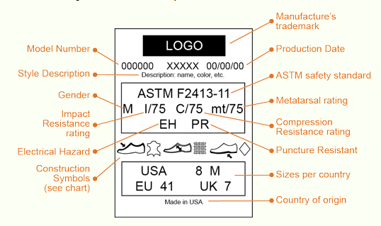
Sample Label – the key requirements are highlighted in red

If you have any questions regarding safety footwear, please contact Environmental Health & Safety. http://safety.uoregon.edu/ 541-346-3192
I have read and understand that I must purchase a safety shoe that fit the above requirements
Employee Initials: _______________ Date: _______________

