**LOCKOUT/TAGOUT DEVICES**

This appendix includes examples of lockout/tagout devices that may be utilized within the scope of the University of Oregon’s Lockout/Tagout Program. Machinery and equipment must be de-energized and locked/tagged out at the source(s) of the energy before maintenance, repair, or modifications can be made. Lockout/tagout devices are placed to prevent the re-energization of equipment before work is complete. Example lockout/tagout devices include:

1. Example lockout lock and key:



1. Example tagout tag:

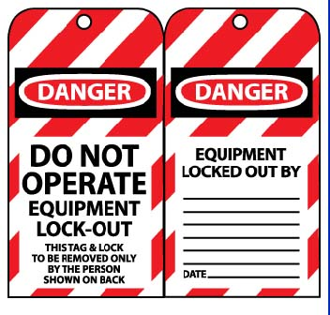

1. Example breaker lockout:

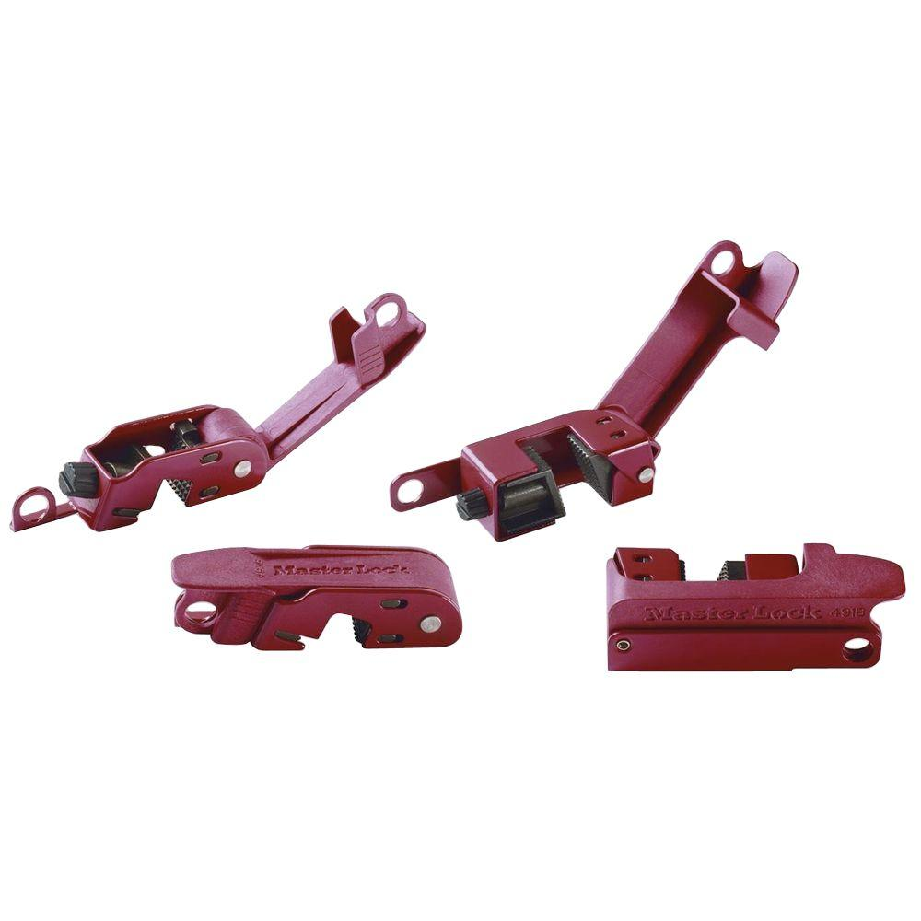

1. Example switch lockout:



1. Example plug lockout:

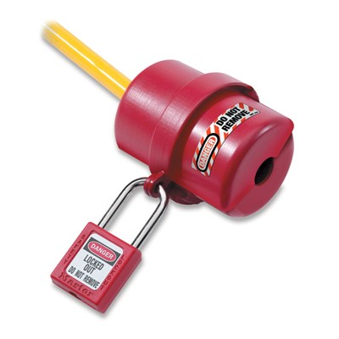

1. Example adjustable cable lockout:

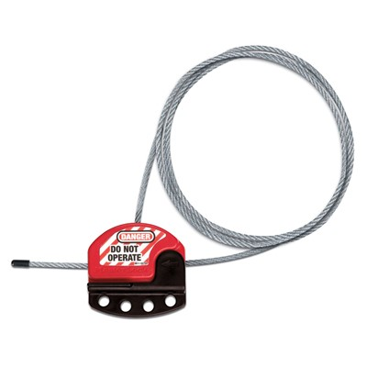

1. Example gate valve lockout:

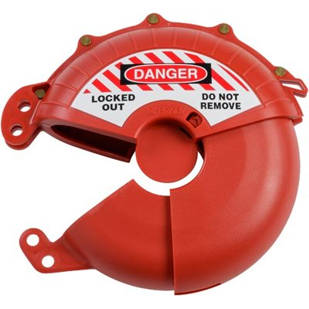

1. Example plug valve lockout:

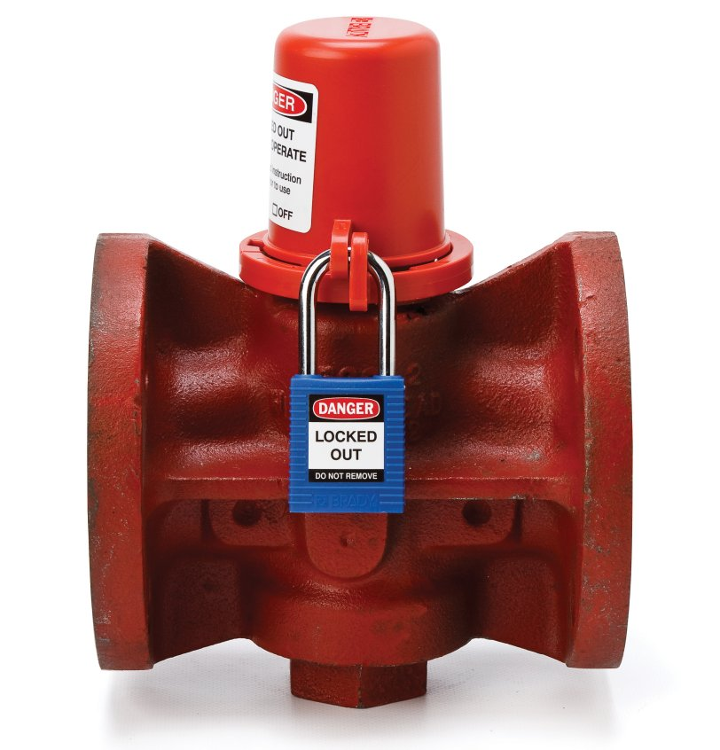

1. Example pneumatic fitting lockout:

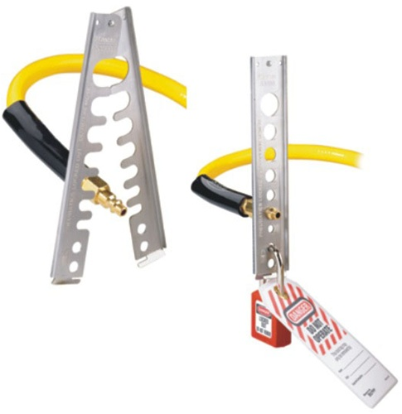

1. Example hasp lockout (for groups):

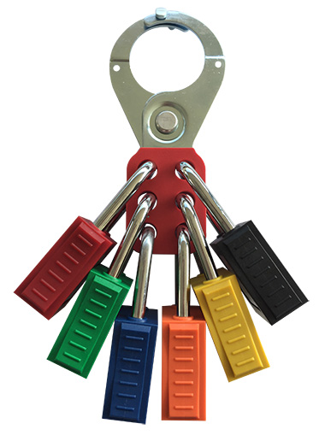

1. Example group lockout box:

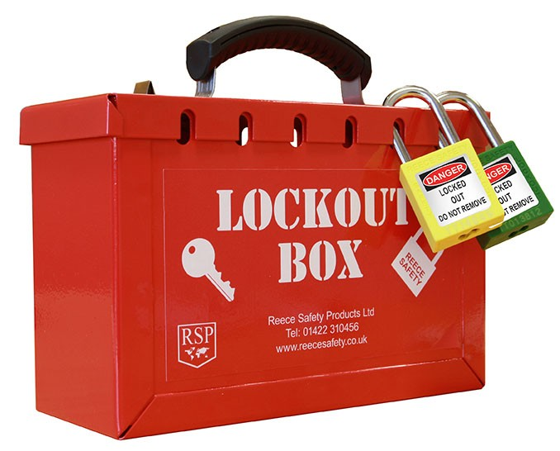

1. Example workplace lockout station:

