Date should be current

Insurance broker name and address

Tenant, vendor or contractor name and address
Insurance carriers who insure the policies (A.M. Best rating www.ambest.com).*

X
x x
Dates of coverage. Policy must be in force for duration of contract or event

$1,000,000

$1,000,000
$2,000,000
$2,000,000

Dates of coverage.
X Policy must be in
force for duration of contract or event
X X
$1,000,000

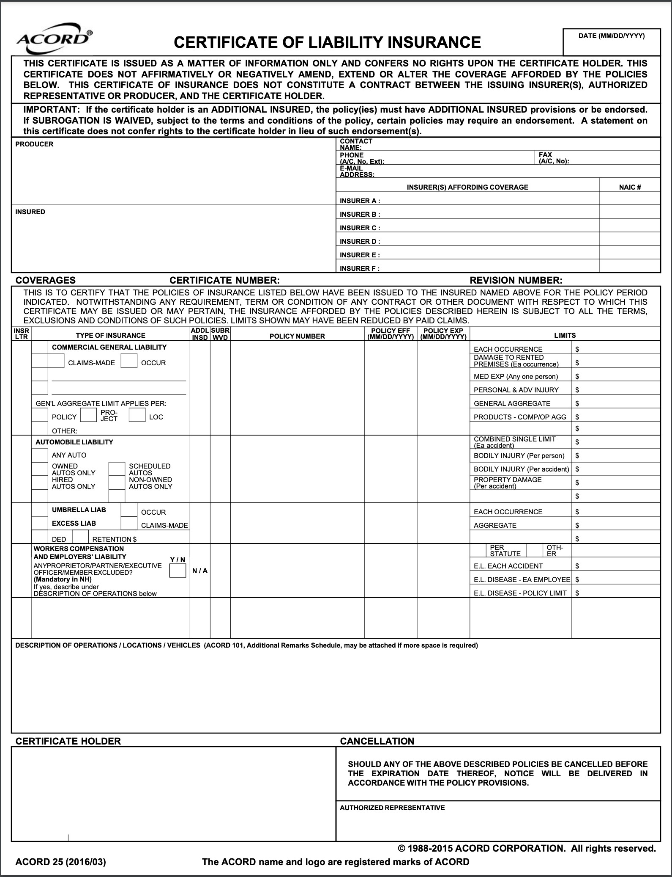

Event information (location, dates, times or contract number
State of Oregon, Board of Trustees to the University of Oregon, University of Oregon and Their Respective Officers, Employees, members are named additional insured

University of Oregon
(Insert Department Name Here Insert Dept Street Address) Eugene, OR 97403

