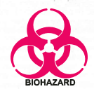 Biohazard, rsNA & Pathological Waste Disposal Guidelines 
 | Sharps Waste | Solid Biohazard Waste | Liquid Biohazard Waste | Solid rsNA Materials | Pathological Waste
Description | 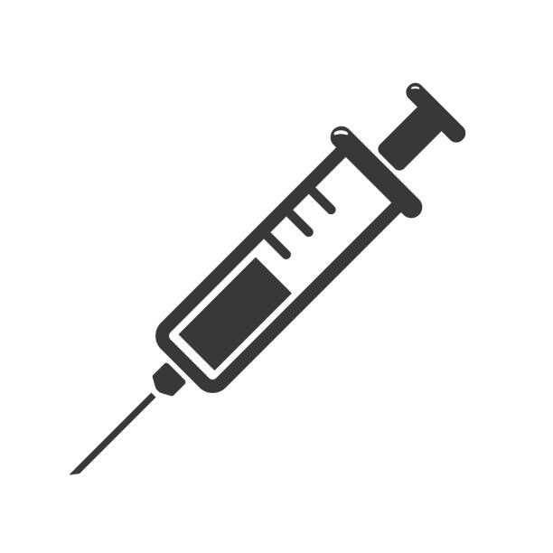  Any and all syringes and sharps, regardless if contaminated with rsNA or biohazardous materials: hypodermic needles, needles with syringes or tubing, syringe bodies, lancets, blades, scalpels, glass. | Any of the following contaminated with biohazardous materials: plastic pipettes, pipette tips, syringes without needles, petri dishes, culture flasks, paper towels, bench paper, biohazardous animal bedding, gloves  No Sharps or Liquid Waste. | 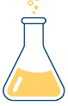  Liquid biohazardous cultures or specimens, including human and animal blood, body fluids, tissue culture, infectious microorganisms, spent growth media, rsNA and viruses. | Only non-pathogenic /  noninfectious materials:  - All genetically modified E.coli, yeast, Drosophila, C.elegans.  - All genetically modified plants.  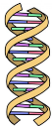  - All recombinant or synthetic nucleic acid molecules. | Human or animal body parts, organs, tissues, surgical specimens and carcasses (removed of formaldehyde, formalin, or other preservatives). Prion waste. All genetically modified animals, including rodents and zebrafish.
Storage &  packaging | Use an approved sharps  container. Container must be red, leak proof, rigid, puncture resistant and tightly lidded. Seal closed when ready for disposal. | Place in red biohazard bag in a rigid, leak proof container with a tight-fitting lid. Or collect in smaller Biohazard waste bags. Or dispose directly into lined EHS-provided Biohazard waste box. | Use a leak proof container with a lid. Store in a secondary container at site of generation. | Rigid waste bin lined with autoclave safe bag (preferably lidded) and labeled for autoclaving. Red bag/biohazard symbol not applicable. | Rigid waste bin lined with Biohazard waste bag (preferably lidded) and labeled Pathological Waste only. Collected in lab freezer until request submitted to EHS for disposal.
Labeling | Biohazard symbol on sharps container if contact with BSL2 materials or human sourced materials. | Biohazard symbol on sides and labelled BIOHAZARD WASTE.  No Pathological waste allowed. | Identify contents and indicate contents are disinfected with fresh 1:10 bleach OR  Biohazard symbol (if untreated) and identity contents of liquid waste. | Clearly label waste can for autoclaving so custodial doesn’t empty as non-hazardous waste. | Biohazard waste bag labeled Pathological Waste only.  Do not mix with Biohazardous waste.
Treatment | Off-site treatment by biowaste vendor (autoclaving or by incineration). | Off-site treatment by biowaste vendor (autoclaving or by incineration). | Treat at site of generation with bleach at 1:10 final dilution for 30 minutes OR  Steam sterilize, only in autoclave dedicated for waste treatment, use standard operating procedures and quality control checks. | Transport using secondary containment. Steam sterilize in an autoclave, use standard operating procedures and quality control checks. | Sent off-site for treatment by incineration only (Oregon Health Authority requirement).
Disposal | Submit waste pickup request though EHSA. Collected by EHS at lab collection locations or can be placed inside Biohazard waste box. | Submit waste pickup request though EHSA. Identify waste request as Biohazard (not Pathological). Collected from lab by EHS. | Pour treated liquids down laboratory sink.  Never autoclave bleach treated waste. | After autoclaving, dispose as regular lab trash in building dumpster.  No biohazard symbol or red bags allowed. | Submit waste pickup request though EHSA. Identify waste request as Pathological (not Biohazard). Collected by EHS at designated lab collection locations.
Mixed  Waste | Before generating mixed waste (i.e., mixture of biohazardous and chemical or radioactive waste), call Environmental, Health & Safety: (541) 346-3192.  Disinfectants other than bleach must be evaluated and approved by Environmental Health & Safety.
Call EHS if you have questions: (541) 346-3192 3/2025
rsNA = recombinant or synthetic nucleic acid molecules

