

LASER SAFETY PROGRAM MANUAL

Environmental Health and Safety
72 Onyx Bridge
541-346-3192
ehsinfo@uoregon.edu

UO LASER SAFETY PROGRAM
Table of Contents
Scope 2
Laser PI And LLSO Responsibilities 2
EHS Responsibilities 3
Laser Classes 3
Training Requirements 5
Medical Surveillance 6
Control Measures 6
Responsibilities of Laser Users 7
Entryway Signage Requirements 7
Audits 8
Records 8
References – Informational Sources Reviewed 9
Appendices 10
Appendix A: Laser Registration, Acquisition, Transfer, and Disposal Form 11
Appendix B: Laser Hazard Evaluation – (Multi-) Laser System 13
Appendix C: Standard Operating Procedures Form 18
Appendix D: PPE Guidelines for Laser Operations Operating Procedures Form 21
Appendix E: Post Incident Reporting Sheet 23
Appendix F: Laser Safety Self-Assessment Form (General) 24
Appendix G: Laser System Safety Self-Assessment Form 26
Appendix H: Laser Safety Calculation Guide 28
Appendix I: Laser Emergency Response 29
Appendix J: Laser Safety Briefing Form 30
Appendix K: Class 4 Laser Danger Sign Template 32
Appendix L: Class 3B Laser Warning Sign Template 33
Appendix M: Class 4 Laser Warning Sign Template 34
Appendix N: Laboratory Safety Training Worksheet 35

SCOPE
This program applies to all lasers and laser systems operated by University of Oregon staff. It is based on the ANSI Z136.1-2022 American National Standard for Safe Use of Lasers. Proper implementation of this program will ensure that laser exposures remain below the maximum permissible exposure (MPE) limits.

LASER PI and LLSO RESPONSIBILITIES
Each Principal Investigator (PI) or Supervisor overseeing a university space with operational Class 3B and/or Class 4 lasers must designate a Lab Laser Safety Officer (LLSO). The LLSO, under the supervision of the PI/Supervisor, is responsible for ensuring compliance with this Laser Safety Program.

The LLSO is responsible for the following:

- Ensure proper classification of all lasers.
- Register all Class 3B and 4 lasers with EHS and notify EHS of any laser transfers or disposals (see Appendix A).
- Perform hazard evaluations for all systems and laser work areas containing Class 3B and/ or Class 4 lasers (see Appendix B).
- Specify and implement control measures for all Class 3B and 4 lasers (see Appendix B).
- Develop written procedures (SOPs) for each system involving a Class 4 laser (see Appendix C).
- Ensure appropriate protective equipment is available and accessible (see Appendix B and Appendix D).
- Ensure that all required signage and labeling are completed and posted, including entryway signs for Laser-Controlled Areas and any hazard or identification labels on laser equipment, in accordance with ANSI Z136.1-2022 and UO EHS policy.
- Verify that all laser personnel receive appropriate safety training (See Appendix N).
- Ensure that all laser users, regardless of laser class, complete the Laser Safety Briefing Form (see Appendix J) before operating any laser system.
- Maintain records including all forms from appendices and training documentation.
- Submit completed Appendices A, B, and C to EHS prior to operating Class 3B or Class 4 lasers, and any time systems are added, relocated, or significantly modified in a way that may require a new hazard assessment.
- Report all injuries to Safety Risk Services (SRS)/EHS (see Appendix E).

The designated LLSO, under supervision of the PI/Supervisor, shall have authority in determining laser control measures and may approve alternate controls when these are appropriate based on the judgment of the PI/Supervisor. Class 3B and Class 4 lasers shall be operated by lab staff only with the written approval of the LLSO. The LLSO shall have the authority to terminate laser operations at any time if unsafe practices are observed.

EHS RESPONSIBILITIES
- Make available Laser Safety Training which includes general topics of laser characteristics and classes, control measures, beam and non-beam hazards, and injury response.
- Provide standardized entryway signage templates for Laser-Controlled Areas (LCAs), in compliance with ANSI Z136.1-2022 and University of Oregon Environmental Health and Safety (UO EHS) requirements. It is the responsibility of the lab to complete the appropriate template and post signage at each LCA entry point.
  - Class 4 signs must include: laser class and hazard, laser type, average power, required protective eyewear OD and wavelength, and contact information for the designated LLSO.
  - Class 3B signage must include laser class and LLSO contact information (OD and wavelength are not required).
  - Appendix L: Template for Class 3B signage
  - Appendix K: Template for Class 4 signage
- Maintain records of laser registrations submitted by users.
- Maintain records of reported injuries and conduct follow-up investigations as needed.
- Conduct periodic inspections of laser use areas in coordination with the PI/Supervisor and designated LLSO.
- Review and update Laser Safety Program documents annually.

LASER CLASSES
All laser users, regardless of laser class, must complete the Laser Safety Briefing Form (see Appendix J) before operating any laser system. This briefing ensures users understand potential hazards, safe operating procedures, and relevant responsibilities. The requirement applies to all classes, including Class 1, 1M, 2, 2M, and 3R, which may not otherwise require full Laser Safety Training.
Class 1 laser systems are incapable of producing damaging radiation levels during normal operation and are exempt from any control measures. These systems operate at or below the Maximum Permissible Exposure (MPE) for any accessible exposure conditions, considering worst-case parameters (wavelengths from 180 nm to 1 mm and exposure durations from 0.25 seconds to continuous).

Note: Class 1 systems with embedded Class 3B or Class 4 lasers pose additional risks if interlocks or protective housings are bypassed. In such cases, only trained and authorized personnel may operate the system under supervision and in accordance with approved safety procedures.
Class 1M laser systems emit collimated or divergent beams that are not hazardous for unaided viewing under normal operation but may be hazardous if viewed with optical instruments such as telescopes or microscopes. These systems typically emit in the 302.5 nm to 4,000 nm range.
Class 2 laser systems emit only in the visible portion of the electromagnetic spectrum (400–700 nm) and do not exceed 1 milliwatt (mW) of continuous wave (CW) power. The natural aversion response to bright light (within 0.25 seconds) is generally sufficient to provide eye protection. Intentionally staring into the beam is hazardous.
Class 2M laser systems also emit only in the visible range (400–700 nm) and have the same 1 mW power limitation as Class 2, but the beam may be hazardous when viewed with optical instruments.

Class 3R laser systems emit between 302.5 nm and 1 mm and have output powers up to:
- 5 mW for visible CW lasers (400–700 nm), or
- Five times the Class 1 limit for other wavelengths and exposure durations.
Although potentially hazardous under direct viewing, the risk of injury is low and control measures are relatively simple. Most laser pointers fall into this category.

Class 3B laser systems operate at power levels:
- Between 5 mW and 500 mW for visible CW lasers, or
- Between five times the Class 1 limit and ten times the Class 1 limit for pulsed or invisible lasers, depending on the duration and wavelength.
These lasers pose eye hazards from direct beam exposure and specular reflections, even for brief exposures. Diffuse reflections are generally not hazardous.
Class 3B lasers must be operated only in Laser-Controlled Areas by trained and authorized personnel. Operators must complete approved Laser Safety Training.

Class 4 laser systems exceed the limits for Class 3B and can cause:
- Eye and skin injuries from direct exposure or reflections (specular or diffuse),
- Fire hazards, and
- Production of laser-generated air contaminants (LGACs) and plasma radiation.
Class 4 systems may operate at high power levels (>500 mW for visible CW lasers or above applicable limits for pulsed/invisible lasers).
Operation is restricted to LCAs under strict administrative and engineering controls.
Operators must complete approved Laser Safety Training, and a written Standard Operating Procedure (SOP) is required for each Class 4 system.

LASER REGISTRATION AND REQUIRED SUBMISSIONS
Prior to the operation of any Class 3B or Class 4 laser, the following forms must be completed and submitted to Environmental Health and Safety (EHS):
- Appendix A - Laser Registration, Acquisition, Transfer, and Disposal Form
- Appendix B – Laser Hazard Evaluation Form
- Appendix C – Standard Operating Procedure (SOP) Form
These documents must be submitted when a new laser is required, when a system is relocated, or when significant modifications are made that may affect the laser’s hazard classification or require a new hazard assessment. Submission is also required as part of the lab’s initial enrollment in the Laser Safety Program.

During annual inspections, EHS will also review additional records maintained by the lab, including training documentation (Appendix N), Laser Safety Briefings (Appendix J), and annual self-assessments (Appendices F and G).

TRAINING REQUIREMENTS
All operators of Class 3B and Class 4 lasers must complete the online Laser Safety Training through MyTrack (for employees) or Community Canvas (for students and affiliates) before beginning laser work and annually thereafter.
- Employees: Laser Training on MyTrack
- Students and Affiliates with a uoregon email address: Contact ehsinfo@uoregon.edu to request an invitation to the EHS Community Canvas Training Course.
In addition, all users must receive lab-specific, in-person laser safety training addressing the specific hazards, controls, and procedures for the laser system they will use.

All trainings—both online and in-person—must be documented, including the name of the trainer, the date of completion, and the signature (if in-person) of the trainee and trainer. The Laboratory Safety Training Worksheet (Appendix N) may be used to track and document completion of required laser safety trainings.

MEDICAL SURVEILLANCE
An eye exam is required immediately following a suspected hazardous exposure. Laser personnel shall report any suspected hazardous exposure to the PI/Supervisor or Lab Laser Safety Officer immediately and submit an injury report within 24 hours of the incident (see Appendix E).

LCA CONTROL MEASURES
All Class 3B and 4 lasers shall only be operated in a laser-controlled area (LCA). The minimum requirements for laser-controlled areas are:
- Entryway controls to allow only authorized personnel or approved spectators to enter the laser control area. (Administrative controls are acceptable.)
- Laser safety eyewear of the appropriate OD for each laser system available and used in accordance with the SOP for Class 3B and class 4 lasers (see Appendices B, C, D, H & I).
- Beam control (barriers and beam blocks) to limit laser hazards within the controlled area.
- Written SOP for Class 3B and 4 lasers approved by the LLSO and available at the laser setup for reference (see Appendix C).
- Training of operators of all Class 3B and 4 lasers.
- Compliant warning signage must be posted at all hallway entry points.
  - Class 3B signage must include laser class and LLSO contact info.
  - Class 4 signage must include laser class and hazard, required protective eyewear OD and wavelength, and contact information for the designated LLSO (see Appendices L and M). For Class 4 lasers with multi-kilowatt output or high pulse energy and exposed beams, signage must include the “Danger – Class 4 Laser Controlled Area” warning (see Appendix M).

In addition to the minimum requirements listed above, ANSI Z136.1 specifies that a Class 3B LCA should and a Class 4 LCA shall meet the following conditions:
- Be under the direct supervision of an individual knowledgeable in laser safety.
- Have only diffusely reflecting materials in or near the beam path.
- Terminate hazardous beams using an appropriate beam stop.
- Limit access by spectators.
- Store or disable the laser when not in use.
- Ensure beam path is located above or below eye level of a sitting or standing person.
- Cover or restrict all windows, doors, or open portals such that laser radiation remains below the Maximum Permissible Exposure (MPE).

The requirements beyond the minimum for individual laser-controlled areas shall be determined by the PI/Supervisor and LLSO.

RESPONSIBILITIES OF LASER USERS
- Complete required online and lab-specific in-person training before operating a laser system. Training must be refreshed annually and documented. Documentation may be recorded using the Laboratory Safety Training Worksheet (Appendix N). Users must also review the SOPs they use annually (Appendix C).
- Employees who work with class 3B or 4 lasers with the beam exposed shall:
  - Energize or work with lasers only when authorized to do so.
  - Comply with laser safety rules and work procedures.
  - Immediately notify their supervisor and/or the Lab Laser Safety Officer (LLSO) in the event of a potential accident, injury, or suspected unsafe condition. All work-related injuries must be reported to Safety and Risk Services (SRS) within 24 hours of the incident (Appendix I).

ENTRYWAY SIGNAGE REQUIREMENTS
Entryway warning signs are required for all Class 3B and Class 4 Laser-Controlled Areas (LCAs) in accordance with ANSI Z136.1-2022 and UO EHS policy.
- Signage must be posted at all entryways to LCAs where Class 3B or Class 4 lasers are used.
- Labs are responsible for completing and posting signage. EHS provides templates.
- Class 4 signage must include:
  - Laser class and hazard
  - Laser type and average power
  - Required Optical Density (OD) and wavelength for protective eyewear
  - Name and contact information for the designated LLSO
- For Class 4 lasers with multi-kilowatt output power or high pulse energy and exposed beams, there must be an additional sign stating “Danger – Class 4 Laser Controlled Area”.
- Class 3B signage must include:
  - Laser class
  - Name and contact information for the designated LLSO
- Appendix K – Class 4 Laser Danger Sign Template (required only for lasers with exposed beams, high pulse energy, or multi-kilowatt output)
- Appendix L – Class 3B Laser Warning Sign Template
- Appendix M – Class 4 Laser Warning Sign Template (required for all Class 4 Laser-Controlled Areas)

AUDITS
An annual audit of all Class 3B and Class 4 lasers, as well as the overall Laser Safety Program, shall be conducted by the Lab Laser Safety Officer (LLSO). As part of this process, the LLSO will complete the General Laser Safety Self-Assessment Form and a Laser-System Safety Self-Assessment Form for each Class 3B and Class 4 laser in the lab (see Appendices F and G). Environmental Health and Safety (EHS) will conduct an annual inspection in coordination with the LLSO and will be available to provide support throughout the audit process.

RECORDS
The LLSO shall maintain records which document the lab’s participation in the UO Laser Safety Program. These records shall include:
- Copies of Laser Registration, Acquisition, Transfer, and Disposal Form provided to EHS (see Appendix A).
- Laser Hazard Evaluation Form for all class 3B and class 4 lasers, including a clearly labeled diagram of the laser-system and corresponding hazard zones (See Appendix B).
- Maximum Permissible Exposure (MPE), Optical Density (OD), and Nominal Hazard Zone (NHZ) for each laser system with a class 3B or class 4 laser (see Appendices B and H).
- Current signage and training records for all operators, reviewed and updated annually in coordination with EHS.
- Standard Operating Procedures for all class 3B and class 4 lasers (see Appendix C) including laser emergency response (see Appendix I).
- Approvals of alternate laser control measures.
- Completed Laboratory Safety Training Worksheets (Appendix N) or other documentation verifying training completion.

Copies of Appendices A, B, and C must also be submitted to EHS prior to initial laser use and updated as necessary. Other documentation may be reviewed during annual inspections.

REFERENCES – Informational Sources Reviewed
American National Standards Institute. (2022). ANSI Z136.1–2022: Safe use of lasers. Laser Institute of America.
University of Colorado Boulder. (2022). Laser safety manual. Environmental Health & Safety. https://www.colorado.edu/ehs/sites/default/files/attached-files/laser_safety_manual.pdf
University of Maryland. (2020). Laser safety program manual. Environmental Safety, Sustainability & Risk. https://essr.umd.edu/sites/default/files/2020-11/laser_safety_manual.pdf
University of Rochester. (2023). Laser safety program. Environmental Health & Safety. https://www.safety.rochester.edu/safetyinfo/lasersafety.html
University of Chicago. (2020). Laser safety program – Appendix B: Laser safety calculations. Environmental Health & Safety. https://safety.uchicago.edu/page/laser-safety-program
Oregon State University. (2023). Laser safety manual. Environmental Health & Safety. https://ehs.oregonstate.edu/sites/ehs.oregonstate.edu/files/pdf/laser_safety_manual.pdf
University of Oregon. (2023). Chemical hygiene plan (11th revision). Environmental Health & Safety. https://safety.uoregon.edu/sites/default/files/2023-10/chemical-hygiene-plan_11th_revision_2023.pdf
University of Oregon. (2015). Laser safety program manual [Previous internal version]. Environmental Health & Safety.

APPENDICES
Appendix A: Laser Registration, Acquisition, Transfer, and Disposal Form
Appendix B: Laser Hazard Evaluation Form
Appendix C: SOP Template for Laser Use and Safety
Appendix D: Personal Protective Equipment (PPE) Guidelines for Laser Operations
Appendix E: Post-Incident Reporting Sheet
Appendix F: Laser Safety Self-Assessment Form (General)
Appendix G: Laser-System Safety Self-Assessment Form
Appendix H: Laser Safety Calculations Resources and Links
Appendix I: Laser Emergency Response
Appendix J: Laser Safety Briefing Form
Appendix K: Class 4 Laser Danger Sign Template
Appendix L: Class 3B Laser Warning Sign Template
Appendix M: Class 4 Laser Warning Sign Template
Appendix N: Laboratory Safety Training Worksheet

Appendix A: Laser Registration, Acquisition, Transfer, and Disposal Form
Use this form to register all lasers, report new acquisitions, internal or external transfers, and disposals. All lasers must be registered with EHS (ehsinfo@uoregon.edu). The laser's serial number will be used as its unique identifier. If a serial number is not available, the PI must assign an ID using the following format: [Initials][First 3 letters of building][Room Number]_[#]. For example: NKNFRA254_1.
Laser Identification
Manufacturer:____________________________________________________________________________________
Model Number:___________________________________________________________________________________
Serial Number (or Assigned ID):________________________________________________________________
Laser Type / Class:_______________________________________________________________________________
Wavelength(s):___________________________________________________________________________________
Maximum Output Power:________________________________________________________________________
Laser Applications (CW/Pulsed, Pulse Rate, Peak Power, etc.):______________________________
Laser Use & Set up
Is Laser Set Up? (Yes/No):
Is Laser in Use? (Yes/No):
Current Location and Ownership
Building:__________________________________________________________________________________________
Room Number:___________________________________________________________________________________
PI / Responsible Party:__________________________________________________________________________
Department:______________________________________________________________________________________
Contact Information:_____________________________________________________________________________
Lab Laser Safety Officer (if applicable):________________________________________________________
Action Being Reported
☐ Registration ☐ Acquisition ☐ Internal Transfer ☐ External Transfer ☐ Disposal
New Building / Institution (if applicable):
Appendix A: Laser Registration, Acquisition, Transfer, and Disposal Form

New Room Number:
New PI / Responsible Party:
New Contact Information:
Method of Disposal (check one): ☐ Return to Manufacturer ☐ E-Waste Disposal ☐ Other:
Hazardous Materials Removed and Disposal Method:
Laser Safety Controls (for in-use lasers only)
Class Warning Label (Yes/No):
Emission Indicator (Yes/No):
Interlocks Functional (Yes/No):
Key Switch or Computer Code (Yes/No):
Beam Attenuator (Yes/No):
Remote Interlock Connector (Yes/No):
Equipment Manual Available (Yes/No):
Protective Housing Label (Yes/No):
Aperture Label (Yes/No):
Manufacturer’s Label (Yes/No):
Certification Label (Yes/No):
Options/Modifications/Comments:__________________________________________________________________________________________________________________________________________________________________________________________________________________________________________________________________________________________________________________________________________________________________________________________________________________________________________________________________________________________________________________________________________________
Certification
I certify that the information provided above is accurate and that all procedures have been followed in accordance with university policies.
Name:___________________________ Signature: ______________________________________ Date: _____________

Appendix B: Laser Hazard Evaluation – (Multi-) Laser System

PI Name:_______________________________________________
Lab Location (Building/ Room):____________________________________
LLSO Name:___________________________________________________________
Date of Evaluation:___________________________________________________
Laser System ID:_______________________________________________________
Purpose
This Laser Hazard Evaluation form is used to assess hazards associated with a laser system, which may include multiple lasers. Each laser should be referenced by its Laser ID, as listed in the lab’s separate Laser Inventory. This evaluation supports compliance with ANSI Z136.1-2022 and helps determine appropriate control measures, signage, and personal protective equipment requirements.
When to Conduct a Hazard Evaluation
- Prior to initial use of a laser system
- When modifications are made to an existing system that alter the laser classification, beam path, control measures, or any other factor affecting the original hazard evaluation
- If the laser system is moved to a new location
- In preparation for annual EHS inspections

Responsibility
The Principal Investigator (PI) and/or designated Lab Laser Safety Officer (LLSO) is responsible for completing the Laser Hazard Evaluation. EHS is available to assist as needed.
Laser System ID Assignment (Required)
Each laser system must be assigned a unique Laser System ID using the format below. This ID is used for hazard evaluation, tracking, and inspection purposes. It applies to the system as a whole, not to individual lasers (which are listed separately in the lab’s Laser Inventory).
Format:
SU-[Building Code]-[Room Number]-[PI Initials]-[System Number]

Appendix B: Laser Hazard Evaluation – (Multi-) Laser System

Components:
- SU: Stands for System Unit, indicating a laser system (not an individual laser)
- Building Code: Abbreviation for building (e.g., KLA, LISB)
- Room Number: Primary room number where the laser system is located
- PI Initials: Principal Investigator’s initials (e.g., Jane Doe Smith → JDS)
- System Number: Two-digit number to distinguish multiple laser systems by the same PI in the same room (01, 02, etc.)
Examples:
- SU-KLA-345-JDS-01
- SU-LISB-220-RBT-02
This ID should also be labeled on the associated laser diagram, referenced throughout the evaluation form, and visibly labeled on the physical laser system itself.

Section 1. Required Diagram-Laser System
Please attach a clearly labeled diagram of your laser system that includes the following components:
- Laser Beam Paths and Nominal Hazard Zones (NHZ): Clearly show the paths of all laser beams (including primary and potentially hazardous reflected beams) and outline the boundaries of the NHZ.
- Exposure Zones with MPE Labels: Identify and label all zones with their corresponding Maximum Permissible Exposure (MPE) levels. Ensure each zone reflects the specific MPE applicable based on distance, wavelength, and exposure duration.
- Laser Eyewear Requirements: Indicate areas where laser protective eyewear is required. For each, specify the laser wavelength(s) and the minimum optical density (OD) needed for adequate protection.

Appendix B: Laser Hazard Evaluation – (Multi-) Laser System
Provide a summary table listing all required protective eyewear for each zone in the diagram. Include Optic Parametric Amplifiers (OPAs) in your calculations.

Laser Eyewear Requirements by Zone:
Exposure Zone | Wavelength Range (nm) | Required OD

- Laser Identification: Clearly indicate the Laser ID of each laser on the diagram. Each laser included in the system must be listed below, with its Laser ID matching the lab’s Laser Inventory.
Provide a summary table listing all lasers in this laser system by Laser ID.
Laser ID | Laser Class

- Engineering Controls and Containment Features: Include all beam stops, barriers, walls, and containment mechanisms used to confine the beam and prevent unintended exposure.

Section 2. Optical Hazard Evaluation Checklist
Have MPEs been calculated for all exposure zones? ______
Has the NHZ been calculated for each laser? ______
Are OD and wavelength requirements documented and labeled on the diagram? ______
Is there risk of specular reflection? ______
Is there risk of diffuse reflection? ______
Are all beam paths fully contained or appropriately controlled? ______

Appendix B: Laser Hazard Evaluation – (Multi-) Laser System
Section 3. Non-Beam Hazards
Indicate any non-beam hazards present and describe control measures.
Hazard Type | Present | Control Measures
High Voltage/ Current | Yes/ No
Chemicals (dyes, solvents, etc.)* | Yes/ No
Fire/Ignition Source | Yes/ No
Ozone Generation | Yes/ No
Laser-generated Air Contaminants | Yes/ No
Cryogenic Materials/ Gases | Yes/ No
Moving Parts/ Mechanical Hazards | Yes/ No
Other (specify):
* Attach SDS sheets for all chemicals used with system.
Section 4. Environmental and Spatial Controls
Are reflective surfaces nearby?

Is the system located in a shared space or area with public access?

Are barriers or beam stops in place?

Are entryway warning signs posted and clearly visible?

Are eyewear stations labeled and accessible?

Are interlocks or access controls in place?

Section 5. Personnel and Usage Context
How many trained operators work with this system?

What is the experience level of operators?

Are optics or beam-expanding elements used?

Is alignment performed? If so, is a low-power or surrogate beam used?

Is bystander access controlled or restricted?

Appendix B: Laser Hazard Evaluation – (Multi-) Laser System
Section 6. Control Measures Checklist
Confirm that the following control measures are in place.
Item | In Place? | Notes
SOPs available | Yes/ No
Appropriate eyewear available | Yes/ No
All personnel working with the system have appropriate documented training | Yes/ No
Appropriate signage and hazard labels posted | Yes/ No
Incident reporting system is in place | Yes/ No

PI Approval: _____________________
LLSO Approval: _____________________
Evaluator’s Name:________________________ Signature: _________________________ Date: ___________________

Appendix C: Standard Operating Procedures Form
Standard Operating Procedure

Principal Investigator:  Phone Number: | Department: | Laser System ID:
Lab Laser Safety Officer:  Phone Number: | Laser System Location: | Date:

- This procedure shall be read and signed annually by all persons who use the laser system listed in this SOP.

- LASER DESCRIPTION AND LAYOUT
- Attach the Laser Hazard Evaluation Form for the laser system used in this protocol.
- Attach the Laser System Diagram for the laser system used in this protocol.

- NORMAL USE OPERATING AND SAFETY PROCEDURES
- Target area preparation:

- Startup procedures (include the manufacturer’s recommended steps AND at what points in the procedure one must put on protective eyewear as well as which eyewear that will be (wavelength(s) and minimum OD):

- Operating procedures (power settings, Q-switch mode, pulse rate, other):

Appendix C: Standard Operating Procedures Form

- Shut down procedures:

- NORMAL USE OPERATING AND SAFETY PROCEDURES
- Alignment Protocol:

- Emergency Procedures:

Appendix C: Standard Operating Procedures Form
- OPERATOR REVIEW
I have read and understood this procedure and its contents and agree to follow this procedure each time I use the laser or laser system.
Name (printed) | Signature | Date

This SOP shall be:
- Read and understand by laser users prior to their initial use of the listed laser system.
- Reviewed by all laser users following any modification to the laser system that affects operational parameters.
- Reviewed annually by all laser users.
- This SOP must be readily accessible and available for reference by laser users.

Appendix D: Personal Protective Equipment (PPE) Guidelines for Laser Operations Operating Procedures Form

Laser Safety Eyewear
Eye protection is crucial when operating Class 3B and Class 4 lasers, as exposure can lead to severe eye injuries. The selection of laser safety eyewear should be based on the laser's wavelength and the required Optical Density (OD) to reduce exposure to safe levels.​
Determining Optical Density (OD):
- Identify Laser Parameters: Determine the laser's wavelength(s), maximum power or energy output, and beam diameter.​
- Calculate the Nominal Hazard Zone (NHZ): Assess the area within which the laser beam exceeds the Maximum Permissible Exposure (MPE).
- Compute Required OD: Using the laser's parameters and the MPE, calculate the necessary OD to attenuate the laser energy to safe levels. This calculation should adhere to the guidelines provided in ANSI Z136.1 – Safe Use of Lasers (see Appendix H for calculators and external resources to assist with OD, MPE, and NHZ calculations).
Optical Density = Log (Maximum Power Density Output/ Maximum Permissible Exposure)
Where Maximum power density output and Maximum permissible exposure are both expressed in the same units of joules/cm2 or watts/cm2
The Maximum Permissible Exposure (MPE) is determined by the American National Standards Institute (ANSI) and is based on the wavelength of the laser. You can find the MPE for your laser by referring to the ANSI Z136.1 (Table 5b ) standard.
Or, an easier method, is to use the Laser Institute of America Free OD calculator.
Laser Eyewear Cleaning Procedure
Laser eyewear should be cleaned with a mild detergent soap and plenty of lukewarm water. Attention should be paid to the parts of the eyewear that directly touch the skin (e.g., bridge of nose, ears) and care should be taken when cleaning and drying the lens to avoid scratches, especially with glass eyewear with dielectric coatings. AVOID harsh chemicals and other cleaning products as they may damage the lens. If your lab does not have an internal sink, please clean the eyewear in the restroom.

Appendix D: Personal Protective Equipment (PPE) Guidelines for Laser Operations Form

Eyewear Labeling and Door Signage:
All Class 3B and Class 4 laser-controlled areas should have appropriate signage indicating the laser's class, potential hazards, and required PPE. Door signage must comply with ANSI Z136.1-2022. Required OD and wavelength must be included on Class 4 warning signage (Appendix M). For some higher-risk lasers, an additional Class 4 danger sign may also be required (Appendix K).
Additional PPE Considerations:
- Skin Protection: For high-powered lasers, especially those emitting in the ultraviolet (UV) or infrared (IR) spectra, skin protection such as lab coats, gloves, and face shields may be necessary to prevent burns or other injuries.​
- Respiratory Protection: In scenarios where laser operations produce hazardous fumes or vapors, appropriate respiratory protection should be used.​

References
American National Standards Institute (ANSI). (n.d.). ANSI Z136: Safe use of lasers.
Environmental Health & Safety (EH&S). (n.d.). Lasers. University of Alabama. Retrieved from https://ehs.ua.edu
Laser Institute of America (LIA). (2018). Guide for the selection of laser eye protection. https://www.lia.org
Phillips Safety. (n.d.). Maximizing protection with laser safety glasses: A guide to calculating optical density. Retrieved from https://www.phillips-safety.com

Appendix E: Post Incident Reporting Sheet
PDF link here

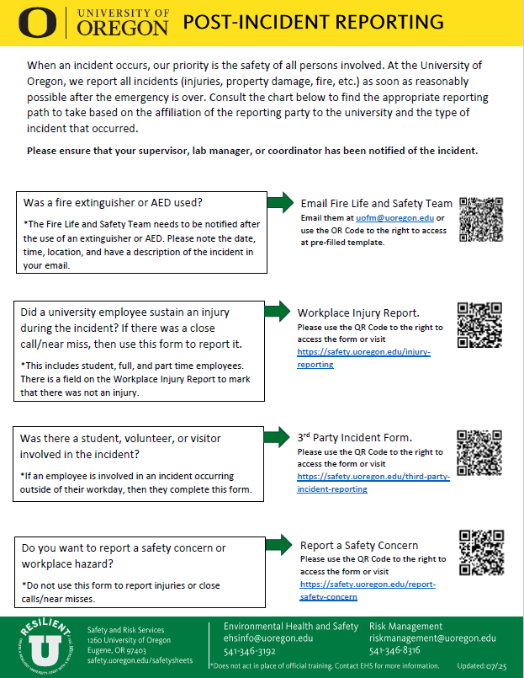

Appendix F: Laser Safety Self-Assessment Form (General)
(Use this form to assist in conducting an annual lab self-assessment. Retain a copy for your records.)

Date: |  | PI:
Building: |  | Self-assessment completed by:
Room(s): |  | Department/Institution:
EHS Representative: |  | Total Number of Class 3B and 4 lasers:  Number in use:
 | Documents and Training |  | Y | N |  | N/A |  |  | Comments
1 | Documentation showing each user has completed online training for working with Class 3B and 4 Lasers. |  | ☐ | ☐ |  | ☐
2 | Documentation showing each user has completed in-person laser training. |  | ☐ | ☐ |  | ☐
3 | SOPs available for all systems with Class 3B and 4 lasers |  | ☐ | ☐ |  | ☐
4 | Entryway signs and interlocks functional |  | ☐ | ☐ |  | ☐
5 | Entryway signs with correct format, emergency contact info, and eyewear OD/wavelength |  | ☐ | ☐ |  | ☐
 | Personal Protective Equipment (PPE) and Non-Beam Hazards
6 | Proper laser eyewear available and labeled with correct OD and wavelength |  | ☐ | ☐ |  | ☐
7 | Eyewear is clean and undamaged |  | ☐ | ☐ |  | ☐
8 | Skin protection used for UV/open beam lasers |  | ☐ | ☐ |  | ☐
9 | Unattended laser operation protocols in place |  | ☐ | ☐ |  | ☐
10 | High voltage hazards minimized |  | ☐ | ☐ |  | ☐
11 | Fiber optics used |  | ☐ | ☐ |  | ☐
12 | Sharps containers used for fiber tools |  | ☐ | ☐ |  | ☐
13 | Fiber ends/connectors labeled |  | ☐ | ☐ |  | ☐
14 | Other non-beam hazards minimized |  | ☐ | ☐ |  | ☐
15 | Are gases/vapors/fumes controlled? |  | ☐ | ☐ |  | ☐

Class 3b and 4 Lasers:

Laser ID # | Registered? | In Use or In Storage?
Appendix F: Laser Safety Self-Assessment Form (General)

Laser ID # | Registered? | In Use or In Storage?

Appendix G: Laser System Safety Self-Assessment Form
(Fill out one for each Laser System containing a Class 3B or Class 4 laser. Retain a copy for your records.)

Date: |  | PI:
Building: |  | Self-assessment completed by:
Room(s): |  | Department/Institution:
EHS Representative: |  | Laser System ID #: | Highest Laser Class in System:
 | Documents and Training |  |  | Y | N |  | N/A |  |  | Comments
1 | All Lasers in System are Registered with EHS |  |  | ☐ | ☐ |  | ☐
2 | Laser System Hazard Evaluation is Complete and Available |  |  | ☐ | ☐ |  | ☐
3 | Standard Operation Procedures Form is Complete, Available, and Signed by All Users |  |  | ☐ | ☐ |  | ☐
4 | Interlock check sheet available and current |  |  | ☐ | ☐ |  | ☐
 | Laser Safety Controls
5 | Laser classification labels present on commercial units |  |  | ☐ | ☐ |  | ☐
6 | Protective housings in place |  |  | ☐ | ☐ |  | ☐
7 | Beam shutters interlocked and functioning |  |  | ☐ | ☐ |  | ☐
8 | Interlock bypass timer operational (≤15 seconds) |  |  | ☐ | ☐ |  | ☐
 | Engineering and Administrative Controls
9 | Beam path: ☐ Totally Open ☐ Completely Enclosed ☐ Combination ☐ Attached Schematic
10 | Beam path Enclosed Using: ☐ Tubes ☐ Perimeter Guards ☐ Panels ☐ Class 1 Product ☐ Fiber
11 | Beam blocks in place: ☐ Secured ☐ Loose ☐ N/A
12 | Lasers and optics secured to table |  |  | ☐ | ☐ |  | ☐
13 | Upward-directed beams labeled |  |  | ☐ | ☐ |  | ☐
14 | Optical devices present (Microscope/ Binocular/ Telescope)? |  |  | ☐ | ☐ |  | ☐
 | Personal Protective Equipment (PPE) and Non-Beam Hazards
15 | Fiber ends/connectors labeled |  |  | ☐ | ☐ |  | ☐
16 | Other non-beam hazards minimized |  |  | ☐ | ☐ |  | ☐
17 | Are gases/vapors/fumes controlled? |  |  | ☐ | ☐ |  | ☐

Laser Controlled Area (LCA) and Nominal Hazard Zone (NHZ)
LCA Description (e.g., Entire Room, Secured Doors): ______________________________________
__________________________________________________________________________________________________

Appendix G: Laser System Safety Self-Assessment Form

NHZ Description (e.g., Behind Barriers): ________________________________

Additional Notes: __________________________________________________________

Appendix H: Laser Safety Calculation Guide

Laser Safety Calculations 2020

Laser Safety Evaluator | The Evaluator | A Product of LIA

Appendix I: Laser Emergency Response
This document outlines the required steps for responding to laser-related emergencies at the University of Oregon, drawing from best practices established by peer institutions and ANSI Z136.1 standards.
Purpose
To provide a standardized and effective response to laser accidents that may result in injury to personnel or damage to property, ensuring timely medical care, proper incident management, and regulatory compliance.
Immediate Response Actions
In the event of a laser accident:
- Shut Down Laser System:
  - Immediately power off the laser device to prevent further exposure.
- Ensure Personnel Safety:
  - Evacuate the area if necessary.
  - Provide first aid if trained and safe to do so.
- Seek Medical Attention:
  - Eye Exposure: Requires urgent ophthalmologic examination, ideally within 24 hours.
  - Skin Exposure: Assess severity; seek care if exposure exceeds MPE.
  - For serious injuries or life-threatening conditions, call 911.
- Preserve the Scene:
  - Do not alter the laser system or work area.
  - Leave the scene intact for investigation.
- Notify Responsible Personnel:
  - Contact the following immediately:
    - Principal Investigator (PI)
    - Laser Lab Safety Officer (LLSO)
    - EHS Incident Response (541) 954-3605
- Report the Incident:
  - Submit an incident report within 1 business day to the EHS Office. Link Here.
  - Notify Workers’ Compensation with 24 hours of incident (if applicable).

Appendix J: Laser Safety Briefing Form
PI/Lab Supervisor:_________________________Lab/Location:___________________________
Laser System ID(s):____________________________________________________________________________
Laser ID(s):____________________________________________________________________________
Laser Class(es): ☐ 1 ☐ 1M ☐ 2 ☐ 2M ☐ 3R ☐ 3B ☐ 4
Briefing Content Checklist
- For All Classes (☑ as discussed):
☐ General laser safety principles and labeling
☐ Biological hazards (eye/skin damage risks)
☐ Avoidance of direct beam exposure
☐ Never defeat interlocks or protective housings without authorization
☐ PPE requirements (if applicable)
☐ Emergency contact information and incident reporting procedure
Class-Specific Topics
- ☐ Class 1
- ☐ System operates below MPE and is exempt from control measures
- ☐ May contain embedded higher-class lasers – not safe if interlocks are bypassed
- ☐ Only authorized personnel may bypass interlocks
- ☐ Class 1M
- ☐ Safe for unaided viewing under normal use
- ☐ Hazardous when viewed with optical instruments
- ☐ Do not use telescopes or microscopes to view the beam
- ☐ Class 2
- ☐ Emits visible light only (400–700 nm)

Appendix J: Laser Safety Briefing Form

- ☐ Power ≤ 1 mW
- ☐ Natural aversion response usually provides protection
- ☐ Do not intentionally stare into beam
- ☐ Class 2M
- ☐ Same power and wavelength range as Class 2
- ☐ Optical instruments may increase risk – avoid their use
- ☐ Class 3R
- ☐ Output ≤ 5 mW (visible CW) or up to 5x Class 1 limit otherwise
- ☐ Potentially hazardous with direct eye exposure
- ☐ Simple control measures typically sufficient
- ☐ No intentional beam exposure
- ☐ Class 3B
- ☐ Power between 5 mW – 500 mW (visible CW) or equivalent
- ☐ Direct beam and specular reflections are hazardous
- ☐ Must be operated in Laser Controlled Area (LCA)
- ☐ Requires formal Laser Safety Training
- ☐ No operation without authorization
- ☐ Class 4
- ☐ Exceeds Class 3B limits
- ☐ Risk of eye/skin injury, fire, and LGACs/plasma radiation
- ☐ Requires engineering/administrative controls
- ☐ Operation restricted to LCA
- ☐ Requires Laser Safety Training + SOP
- ☐ Beam enclosures or beam stops strongly recommended
Operator Certification
I acknowledge that I have received a laser safety briefing relevant to the class of laser system(s) I will be working with. I understand the hazards associated with these systems and agree to follow all safety protocols and procedures.
Operator Name:_________________ Signature: _____________________________ Date: ____________
Trainer Name:___________________ Signature: _____________________________ Date: _____________

Appendix K: Class 4 Laser Danger Sign Template
PDF link here
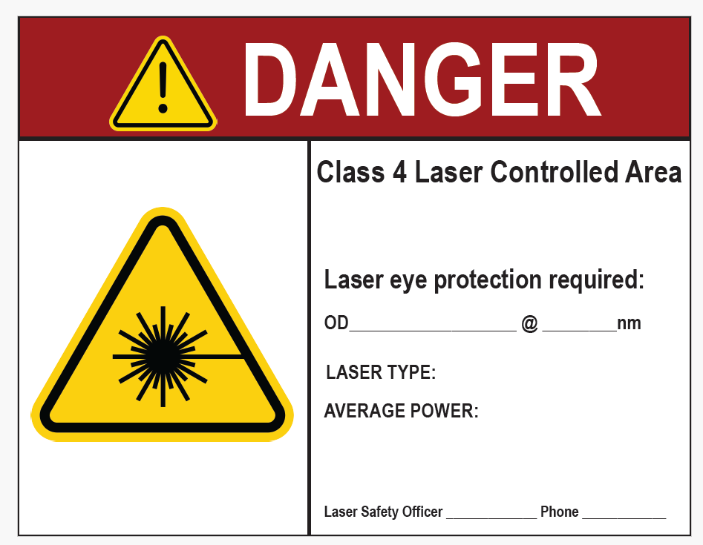

Appendix L: Class 3B Laser Warning Sign Template
PDF link here
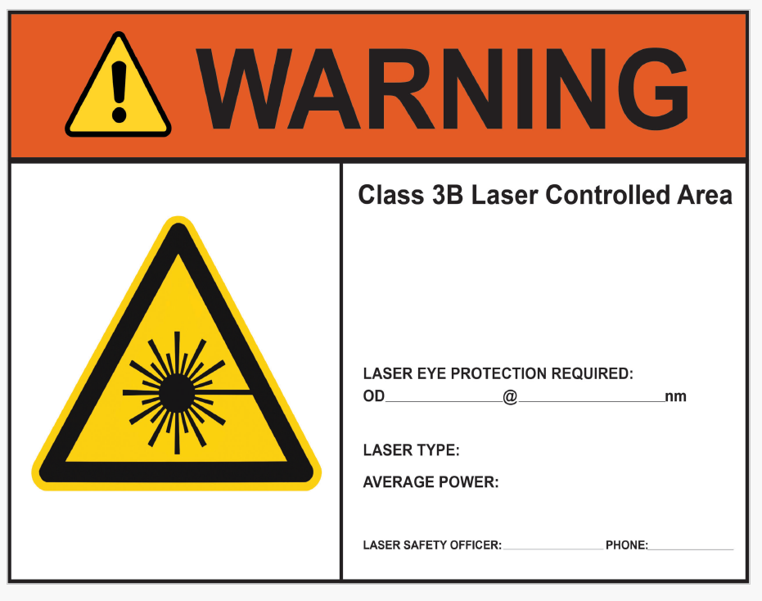

Appendix M: Class 4 Laser Warning Sign Template
PDF link here
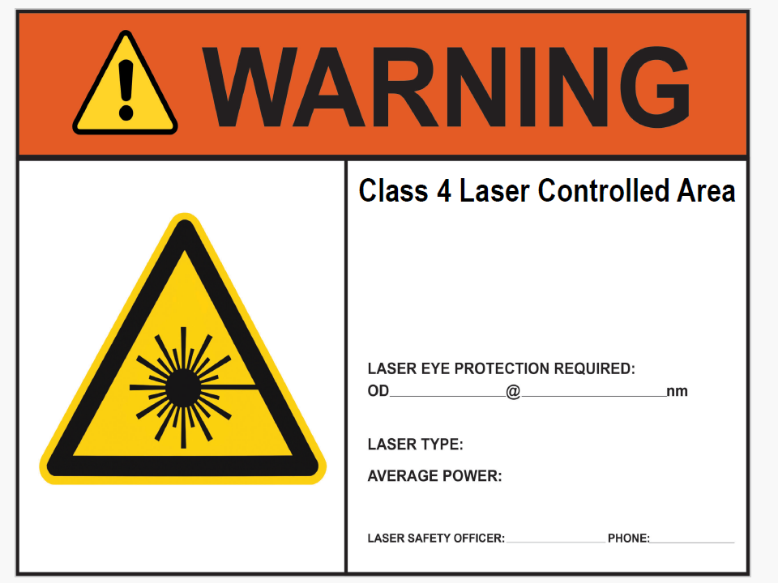

Appendix N: Laboratory Safety Training Worksheet
PDF link here

